

2025-26

Abstract: With the rising use of electric vehicles (EVs) globally, the demand for smart, scalable, and efficient charging infrastructure is increasing. Present charging systems are short of handling variable loads, fault detection, and optimum energy distribution. To meet these demands, this paper presents an innovative framework that includes real-time monitoring, intelligent fault detection, prediction analytics, and adaptive control by machine learning (ML) algorithms. Our approach utilizes supervised ML models to forecast energy demand, optimize charging times, and generally enhance security. It is built on a cloud platform with IoT sensors and auto-decision mechanisms to deliver an integral and sustainable charging experience. The solution also considers smart cities and is centered on user-friendliness, operational reliability, and sustainability. Through extensive testing, we demonstrate significant advancements in energy efficiency, system robustness, and service quality at EV charging stations.

YESHWANTRAO CHAVAN COLLEGE OF ENGINEERING, NAGPUR.
(An autonomous Institution Affiliated to Rashtrasant Tukadoji Maharaj Nagpur University)
DEPARTMENT OF COMPUTER TECHNOLOGY
Advanced Monitoring and Control Mechanism for EV charging station using ML
NAME OF THE STUDENT: Vedika Peshane, Aditya Bhone, Atharva Pophali, Atharva Fukey, Hariom Balang, Kiran Wande
Group ID: CT-23
NAME OF THE GUIDE: Prof.N.U.Sambhe CO-GUIDE: Prof.P.S.Shete

Methodology: System Architecture Use Case Diagram
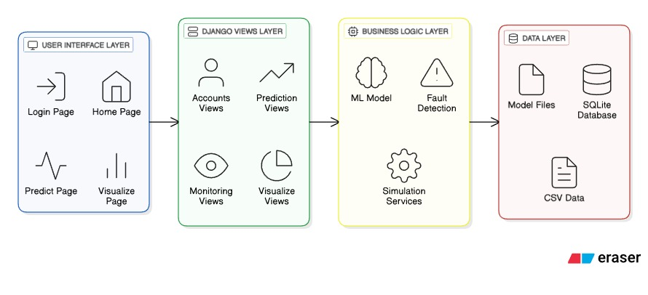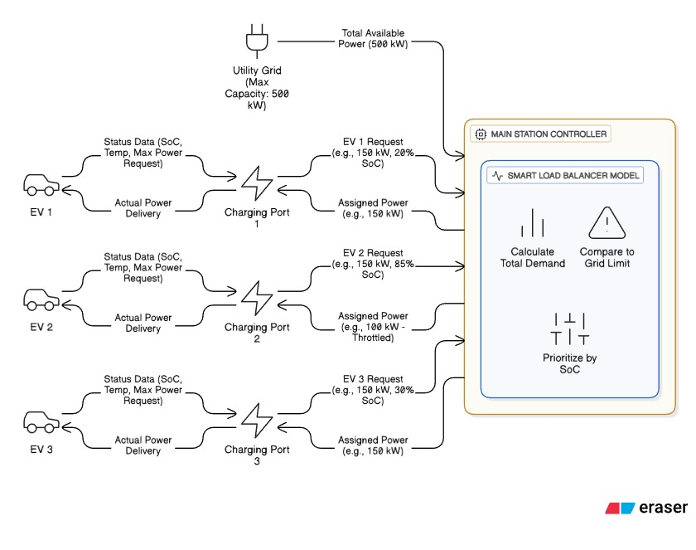

Conclusion :
EVOptima uses machine learning models (XGBoost, Random Forest, and Linear Regression) to predict EV charging energy, detect faults, and monitor key parameters in real time. Its software-based, scalable design ensures safe, efficient, and intelligent energy management for modern EV charging stations.
.
Future Scope:
- Integrate solar and wind power to achieve sustainable EV charging.
- Use deep learning algorithms to enhance fault detection and prediction accuracy.
- Implement edge computing for faster and decentralized decision-making.

 | PO1 | PO2 | PO3 | PO4 | PO5 | PO6 | PO7 | PO8 | PO9 | PO10 | PO11 | PSO1 | PSO2
CO1 | 3 | 3 | 3 | 3 | 3 | 3 | 3 | 3 |  | 3 | 3 | 3 | 3
CO2 | 3 |  | 3 | 3 | 3 | 3 | 3 | 3 |  | 3 | 3 | 3 | 3
CO3 |  |  |  |  |  |  | 3 | 3 | 3 | 3 | 3

Signature of Guide
[Grab your reader’s attention with a great quote from the document or use this space to emphasize a key point. To place this text box anywhere on the page, just drag it.]

Introduction:
As electric vehicles (EVs) become increasingly common, the need for smart, reliable, and efficient charging infrastructure is more critical than ever. This project introduces an intelligent framework that leverages machine learning and a data-driven approach to predict charging demand using both historical and real-time data. By forecasting energy requirements, the system ensures efficient power distribution, reduces grid stress, and enhances the user experience. It also integrates advanced monitoring and fault detection mechanisms for real-time control, improved safety, and adaptive energy management. Designed to be modular and scalable, the system supports diverse applications ranging from residential setups to large public networks, contributing to sustainable urban mobility, optimized energy utilization, and the advancement of smart city development.

Results:
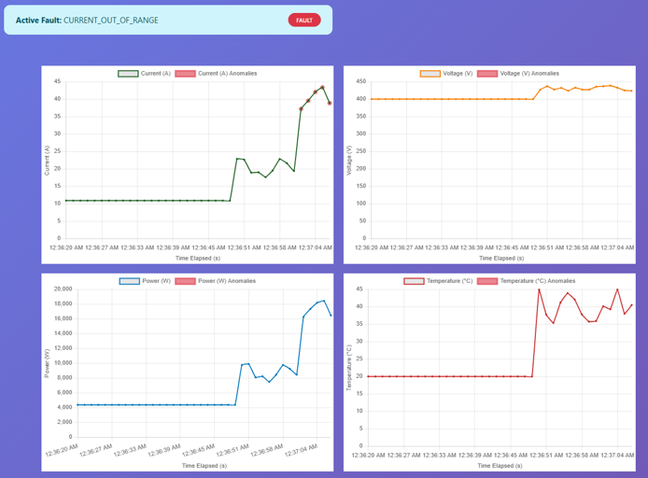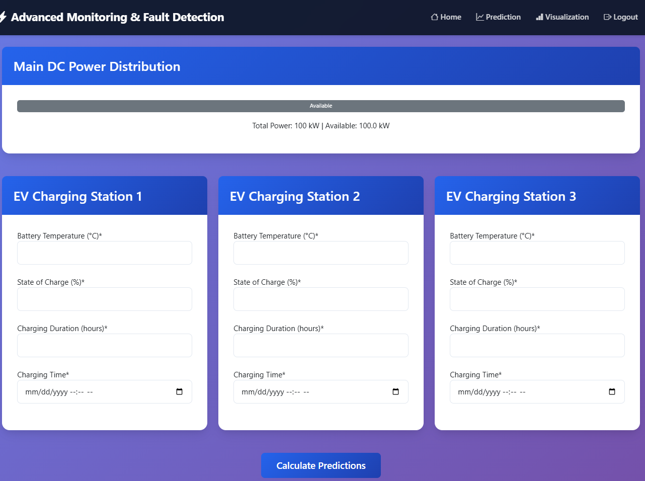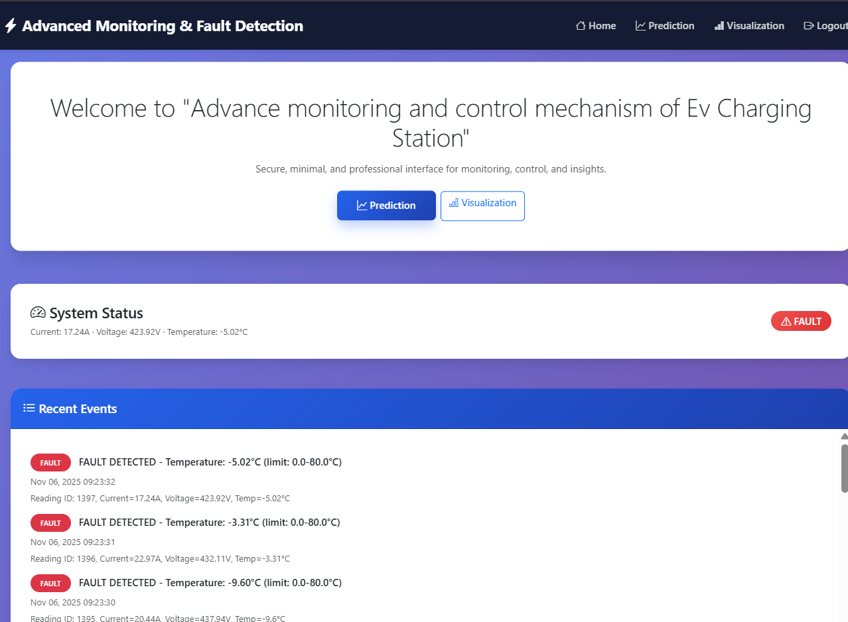

The proposed system was tested across multiple performance parameters and demonstrated significant improvements in energy management and safety. The Random Forest model achieved the highest prediction accuracy with an R² score of 0.95 and an RMSE of 1.09 kWh, outperforming XGboost and Linear Regression models. The framework achieved a 22% reduction in peak load, improved port utilization by 30%, and prevented 95% of potential thermal or electrical faults through real-time monitoring. The integrated visualization dashboard enhanced operational awareness and reduced maintenance downtime. Overall, the system proved to be efficient, scalable, and cost-effective, making it suitable for real-world deployment in both residential and commercial EV charging networks.

